How to Schedule Individual Tutoring Appointments
Step 1: Log into Student Success Hub: https://sso.walshcollege.edu
Step 2: Click on Find Tutors by Course:
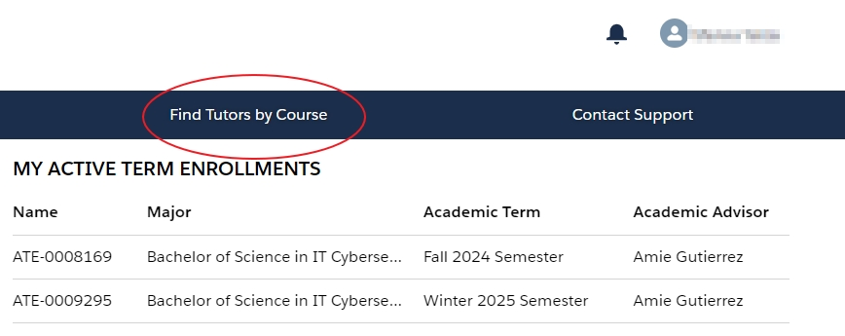

Step 3: Find your course and click on it. Please do not select a course you are not enrolled in. | 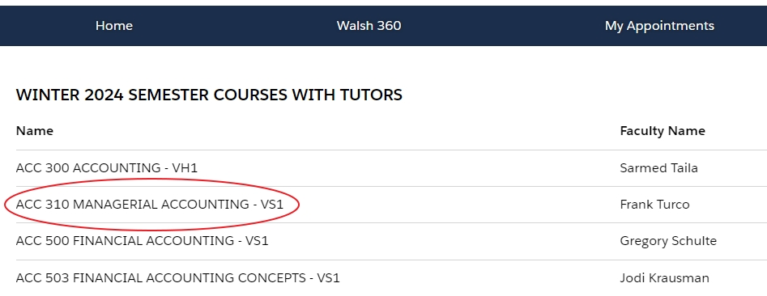

Step 4: Make sure you are on the “Related” tab and if your course has a tutor, they will be listed here. Click on a tutor’s name. | 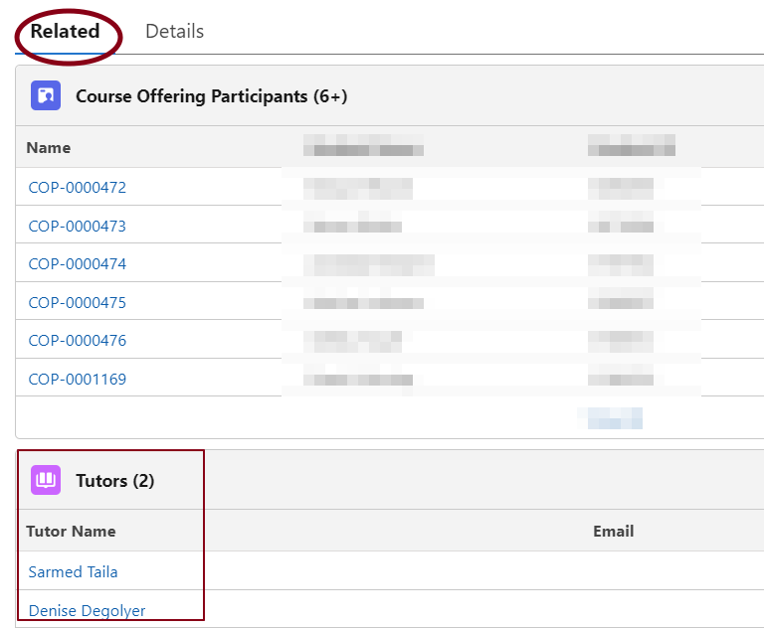

Step 5: Select virtual. All tutoring sessions are being conducted virtually currently. | 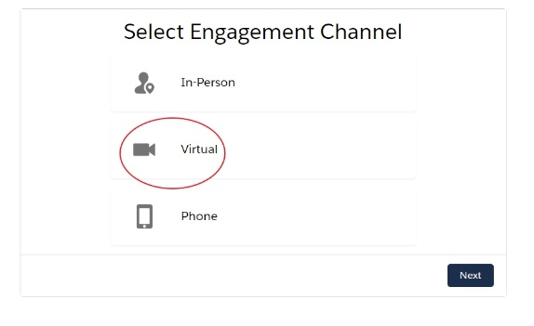

Step 6: Select an appointment time that fits your schedule. Appointments must be at least 24 hours in advance. | 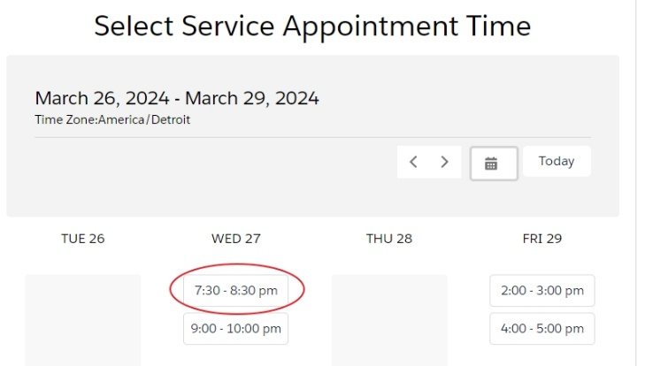
Step 7: Review the Service Appointment information and complete all the General and Contact Information sections.

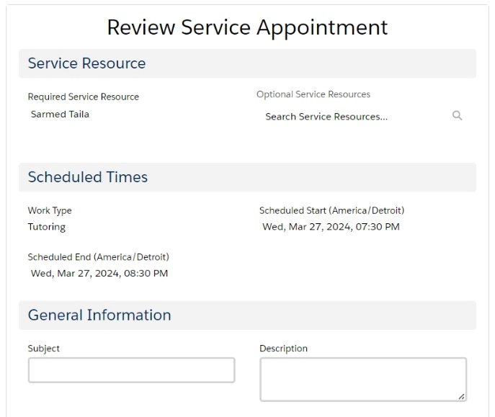 | 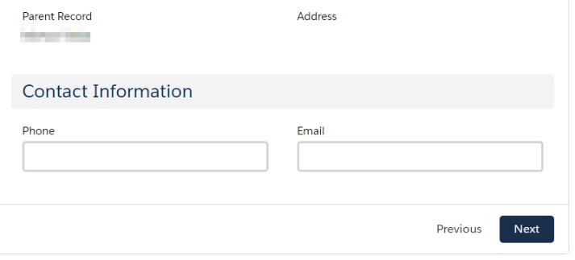

Step 8: Click Finish and you are all set!

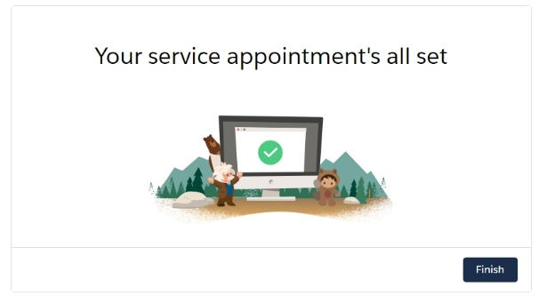

Step 9: To join your tutoring session, click on My Appointments:
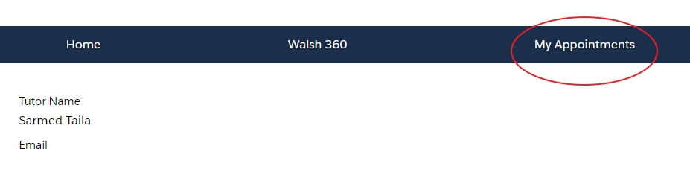
Step 10: Click on View Joining Details:
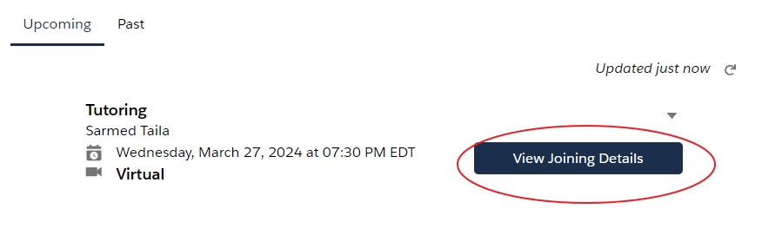
Step 11: Click on the zoom link and you will be connected.

How to cancel a Tutoring Appointment

Step 1: Click on My Appointment
Step 2: Click on the grey arrow. Please remember to cancel an appointment, it must be at least 24 hours before the scheduled appointment. Too many cancellations could result in a suspension of your ability to schedule tutoring.
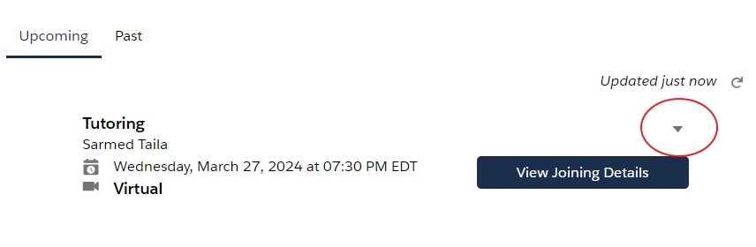

Step 3: Click on Cancel Appointment.

